Open Data

1. 請參考投影片內容，建立以下的Android應用程式

並請將1.**建立過程**; 2.程式**執行結果**截圖; 2.程式**原始檔 copy&paste**置入作業中

1. 請參考範例1,2
   1. 自行挑選一個開放資訊(不可與範例相同),下載即時資訊,分析並於APP內顯示
   2. 請記得修改相關網址,資料結構,JSON解析方式

到data.gov.tw挑選要撈的資料

挑選好之後，複製網址到反白處，要JSON，而且要可以下載下來的才行



到 json parser 找到外層的名稱

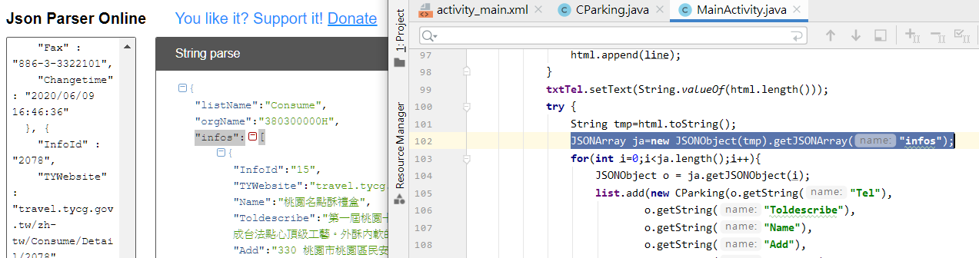

像我外層的名稱叫infos(如左)，所以程式內要修改(如右)，如果外層沒有名稱，可以用另一個範例去改

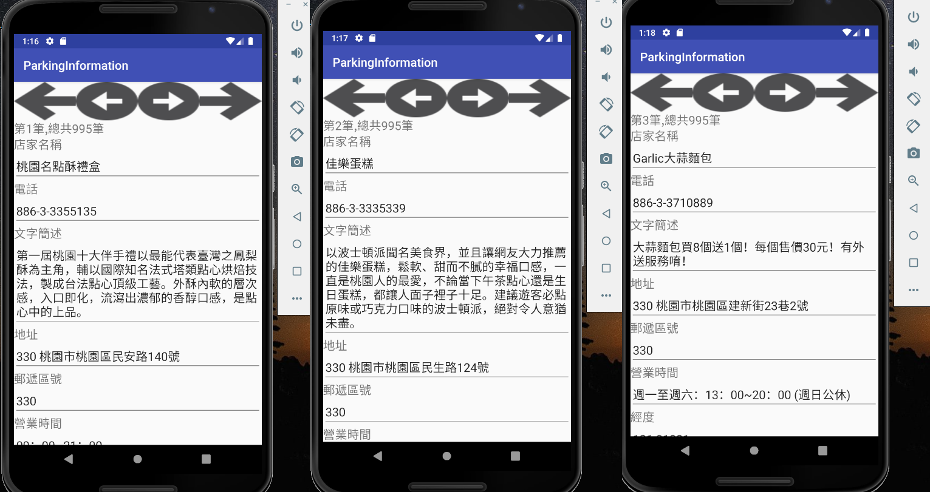

|  |
| --- |
| MainActivity.java |
| **package** parkinginformaiton.ite.mcu.edu.tw.parkinginformation;  **import** android.os.StrictMode; **import** android.support.v7.app.AppCompatActivity; **import** android.os.Bundle; **import** android.view.View; **import** android.widget.Button; **import** android.widget.EditText; **import** android.widget.TextView;  **import** org.json.JSONArray; **import** org.json.JSONException; **import** org.json.JSONObject;  **import** java.io.BufferedReader; **import** java.io.IOException; **import** java.io.InputStream; **import** java.io.InputStreamReader; **import** java.net.MalformedURLException; **import** java.net.URL; **import** java.net.URLConnection; **import** java.util.ArrayList;  **public class** MainActivity **extends** AppCompatActivity {   **private int position**=0;  ArrayList<CParking> **list**;   EditText **txtTel**;  EditText **txtToldescribe**;  EditText **txtName**;  EditText **txtAdd**;  EditText **txtZipcode**;  EditText **txtOpentime**;  EditText **txtPx**;  EditText **txtPy**;  EditText **txtWebsite**;  EditText **txtParkinginfo**;   TextView **txtDatas**;   Button **btnFirst**;  Button **btnPrevious**;  Button **btnNext**;  Button **btnLast**;   @Override  **protected void** onCreate(Bundle savedInstanceState) {  **super**.onCreate(savedInstanceState);  setContentView(R.layout.***activity_main***);   StrictMode.ThreadPolicy l_policy = **new** StrictMode.ThreadPolicy.Builder().permitAll().build();  StrictMode.*setThreadPolicy*( l_policy);   initialComponent();  loadData();  }   **private void** initialComponent() {  **txtTel**=(EditText)findViewById(R.id.***txtTel***);  **txtToldescribe**=(EditText)findViewById(R.id.***txtToldescribe***);  **txtName**=(EditText)findViewById(R.id.***txtName***);  **txtAdd**=(EditText)findViewById(R.id.***txtAdd***);  **txtZipcode**=(EditText)findViewById(R.id.***txtZipcode***);  **txtOpentime**=(EditText)findViewById(R.id.***txtOpentime***);  **txtPx**=(EditText)findViewById(R.id.***txtPx***);  **txtPy**=(EditText)findViewById(R.id.***txtPy***);  **txtWebsite**=(EditText)findViewById(R.id.***txtWebsite***);  **txtParkinginfo**=(EditText)findViewById(R.id.***txtParkinginfo***);   **txtDatas**=(TextView)findViewById(R.id.***txtDatas***);   **btnFirst**=(Button)findViewById(R.id.***btnFirst***);  **btnFirst**.setOnClickListener(**btnFirst_click**);  **btnPrevious**=(Button)findViewById(R.id.***btnPrevious***);  **btnPrevious**.setOnClickListener(**btnPrevious_click**);  **btnNext** =(Button)findViewById(R.id.***btnNext***);  **btnNext**.setOnClickListener(**btnNext_click**);  **btnLast**=(Button)findViewById(R.id.***btnLast***);  **btnLast**.setOnClickListener(**btnLast_click**);    }   **private void** loadData(){  **list**=**new** ArrayList<CParking>();   **try** {  URL url=**new** URL(**"https://data.tycg.gov.tw/opendata/datalist/datasetMeta/download?id=8dc035f1-0770-4522-8c98-96d98bb0530e&rid=9f126a52-5bea-41ff-a769-96b0f1df0f51"**);  URLConnection conn=url.openConnection();  InputStream streamIn=conn.getInputStream();   BufferedReader r = **new** BufferedReader(**new** InputStreamReader(streamIn));  StringBuilder html = **new** StringBuilder();  String line;  **while** ((line = r.readLine()) != **null**) {  html.append(line);  }  **txtTel**.setText(String.*valueOf*(html.length()));  **try** {  String tmp=html.toString();  JSONArray ja=**new** JSONObject(tmp).getJSONArray(**"infos"**);  **for**(**int** i=0;i<ja.length();i++){  JSONObject o = ja.getJSONObject(i);  **list**.add(**new** CParking(o.getString(**"Tel"**),  o.getString(**"Toldescribe"**),  o.getString(**"Name"**),  o.getString(**"Add"**),  o.getString(**"Zipcode"**),  o.getString(**"Opentime"**),  o.getString(**"Px"**),  o.getString(**"Py"**),  o.getString(**"Website"**),  o.getString(**"Parkinginfo"**)  ));  }  displayData();  } **catch** (JSONException e) {  e.printStackTrace();   }   } **catch** (MalformedURLException e) {  e.printStackTrace();  }**catch** (IOException e) {  e.printStackTrace();  }**catch** (Exception e) {  e.printStackTrace();  }   }   **private** View.OnClickListener **btnFirst_click**=**new** View.OnClickListener(){  @Override  **public void** onClick(View view) {  **position**=0;  displayData();  }  };   **private void** displayData() {  **txtDatas**.setText(**"第"**+String.*valueOf*(**position**+1)+**"筆,總共"**+String.*valueOf*(**list**.size())+**"筆"**);  **txtTel**.setText(**list**.get(**position**).getTel());  **txtToldescribe**.setText(**list**.get(**position**).getToldescribe());  **txtName**.setText(**list**.get(**position**).getName());  **txtAdd**.setText(**list**.get(**position**).getAdd());  **txtZipcode**.setText(**list**.get(**position**).getZipcode());  **txtOpentime**.setText(**list**.get(**position**).getOpentime());  **txtPx**.setText(**list**.get(**position**).getPx());  **txtPy**.setText(**list**.get(**position**).getPy());  **txtWebsite**.setText(**list**.get(**position**).getWebsite());  **txtParkinginfo**.setText(**list**.get(**position**).getParkinginfo());  }   **private** View.OnClickListener **btnPrevious_click**=**new** View.OnClickListener(){  @Override  **public void** onClick(View view) {  **position**--;  **if**(**position**<0)  **position**=0;  displayData();  }  };  **private** View.OnClickListener **btnNext_click**=**new** View.OnClickListener(){  @Override  **public void** onClick(View view) {  **position**++;  **if**(**position**>=**list**.size())  **position**=**list**.size()-1;  displayData();   }  };  **private** View.OnClickListener **btnLast_click**=**new** View.OnClickListener(){  @Override  **public void** onClick(View view) {  **position**=**list**.size()-1;  displayData();  }  };  } |
| Cparking.java |
| **package** parkinginformaiton.ite.mcu.edu.tw.parkinginformation;  */**  * Created by MCUMCU on 2017/12/27.  */* **public class** CParking {  **private** String **Tel**;  **private** String **Toldescribe**;  **private** String **Name**;  **private** String **Add**;  **private** String **Zipcode**;  **private** String **Opentime**;  **private** String **Px**;  **private** String **Py**;  **private** String **Website**;  **private** String **Parkinginfo**;   **public** CParking(String Tel, String Toldescribe, String Name, String Add, String Zipcode, String Opentime, String Px, String Py, String Website, String Parkinginfo) {  **this**.**Tel** = Tel;  **this**.**Toldescribe** = Toldescribe;  **this**.**Name** = Name;  **this**.**Add** = Add;  **this**.**Zipcode** = Zipcode;  **this**.**Opentime** = Opentime;  **this**.**Px** = Px;  **this**.**Py** = Py;  **this**.**Website** = Website;  **this**.**Parkinginfo** = Parkinginfo;  }   **public** String getTel() {  **return Tel**;  }   **public void** setTel(String Tel) {  Tel = Tel;  }   **public** String getToldescribe() {  **return Toldescribe**;  }   **public void** setToldescribe(String Toldescribe) {  Toldescribe = Toldescribe;  }   **public** String getName() {  **return Name**;  }   **public void** setName(String Name) {  Name = Name;  }   **public** String getAdd() {  **return Add**;  }   **public void** setAdd(String Add) {  Add = Add;  }   **public** String getZipcode() {  **return Zipcode**;  }   **public void** setZipcode(String Zipcode) {  Zipcode = Zipcode;  }   **public** String getOpentime() {  **return Opentime**;  }   **public void** setOpentime(String Opentime) {  **this**.**Opentime** = Opentime;  }   **public** String getPx() {  **return Px**;  }   **public void** setPx(String Px) {  Px = Px;  }   **public** String getPy() {  **return Py**;  }   **public void** setPy(String Py) {  Py = Py;  }   **public** String getWebsite() {  **return Website**;  }   **public void** setWebsite(String Website) {  Website = Website;  }   **public** String getParkinginfo() {  **return Parkinginfo**;  }   **public void** setParkinginfo(String Parkinginfo) {  Parkinginfo = Parkinginfo;  }  } |
| activity_main.xml |
| *<?***xml version="1.0" encoding="utf-8"***?>* <**ScrollView xmlns:android="http://schemas.android.com/apk/res/android"  android:layout_width="match_parent"  android:layout_height="match_parent"**>    <**LinearLayout xmlns:android="http://schemas.android.com/apk/res/android"  android:layout_width="match_parent"  android:layout_height="match_parent"  android:orientation="vertical"**>  <**LinearLayout  android:layout_width="match_parent"  android:layout_height="wrap_content"**>   <**Button  android:id="@+id/btnFirst"  android:layout_width="match_parent"  android:layout_height="wrap_content"  android:layout_weight="1"  android:background="@drawable/first"** />   <**Button  android:id="@+id/btnPrevious"  android:layout_width="match_parent"  android:layout_height="wrap_content"  android:layout_weight="1"  android:background="@drawable/previous"** />   <**Button  android:id="@+id/btnNext"  android:layout_width="match_parent"  android:layout_height="wrap_content"  android:layout_weight="1"  android:background="@drawable/next"** />   <**Button  android:id="@+id/btnLast"  android:layout_width="match_parent"  android:layout_height="wrap_content"  android:layout_weight="1"  android:background="@drawable/last"** />   </**LinearLayout**>   <**TextView  android:id="@+id/txtDatas"  android:layout_width="match_parent"  android:layout_height="wrap_content"  android:text=""  android:textSize="20dp"** />   <**TextView  android:layout_width="match_parent"  android:layout_height="wrap_content"  android:text="店家名稱"  android:textSize="20dp"** />   <**EditText  android:id="@+id/txtName"  android:layout_width="match_parent"  android:layout_height="wrap_content"  android:textSize="20dp"** />  <**TextView  android:layout_width="match_parent"  android:layout_height="wrap_content"  android:text="電話"  android:textSize="20dp"** />   <**EditText  android:id="@+id/txtTel"  android:layout_width="match_parent"  android:layout_height="wrap_content"  android:textSize="20dp"** />   <**TextView  android:layout_width="match_parent"  android:layout_height="wrap_content"  android:text="文字簡述"  android:textSize="20dp"** />   <**EditText  android:id="@+id/txtToldescribe"  android:layout_width="match_parent"  android:layout_height="wrap_content"  android:textSize="20dp"** />  <**TextView  android:layout_width="match_parent"  android:layout_height="wrap_content"  android:text="地址"  android:textSize="20dp"** />   <**EditText  android:id="@+id/txtAdd"  android:layout_width="match_parent"  android:layout_height="wrap_content"  android:textSize="20dp"** />   <**TextView  android:layout_width="match_parent"  android:layout_height="wrap_content"  android:text="郵遞區號"  android:textSize="20dp"** />   <**EditText  android:id="@+id/txtZipcode"  android:layout_width="match_parent"  android:layout_height="wrap_content"  android:textSize="20dp"** />   <**TextView  android:layout_width="match_parent"  android:layout_height="wrap_content"  android:text="營業時間"  android:textSize="20dp"** />   <**EditText  android:id="@+id/txtOpentime"  android:layout_width="match_parent"  android:layout_height="wrap_content"  android:textSize="20dp"** />   <**TextView  android:layout_width="match_parent"  android:layout_height="wrap_content"  android:text="經度"  android:textSize="20dp"** />   <**EditText  android:id="@+id/txtPx"  android:layout_width="match_parent"  android:layout_height="wrap_content"  android:textSize="20dp"** />   <**TextView  android:layout_width="match_parent"  android:layout_height="wrap_content"  android:text="緯度"  android:textSize="20dp"** />   <**EditText  android:id="@+id/txtPy"  android:layout_width="match_parent"  android:layout_height="wrap_content"  android:textSize="20dp"** />   <**TextView  android:layout_width="match_parent"  android:layout_height="wrap_content"  android:text="網址"  android:textSize="20dp"** />   <**EditText  android:id="@+id/txtWebsite"  android:layout_width="match_parent"  android:layout_height="wrap_content"  android:textSize="20dp"** />   <**TextView  android:layout_width="match_parent"  android:layout_height="wrap_content"  android:text="停車資訊"  android:textSize="20dp"** />   <**EditText  android:id="@+id/txtParkinginfo"  android:layout_width="match_parent"  android:layout_height="wrap_content"  android:textSize="20dp"** />       </**LinearLayout**> </**ScrollView**> |